**2nd Status Report**

**Fitness Tracker – FITFLOW**

**E-Project**

**TEAM MEMEBERS**

|  |  |
| --- | --- |
| Enrollment ID | Student Name |
| Student1434937 | MUHAMMAD KAARIM HUSSAIN |
| Student1438944 | MUHAMMAD ASIM |
| Student1457819 | SUNDUS KHALID KHAN |

**ACADEMIC**

|  |  |
| --- | --- |
| Coordinator | Faculty |
| Miss Sana Yousuf | Sir Owais Khan |

**SEMESTER:** HDSE I



**LANDING PAGE**

Introduction to the website where we will explain and display the features about the website and what do we offer

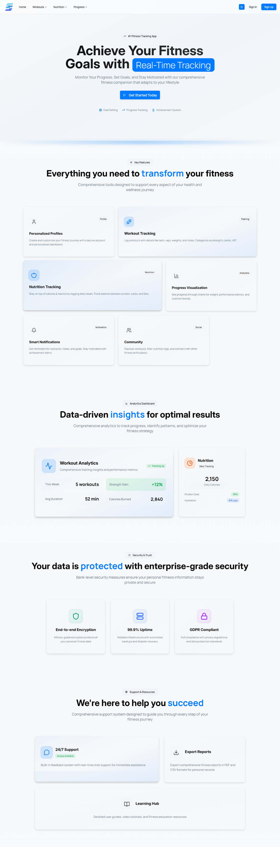

**SIGN IN & SIGN UP**

Making sure that user continue its journey without losing progress, and also making sure that user can start their journey as quickly as possible

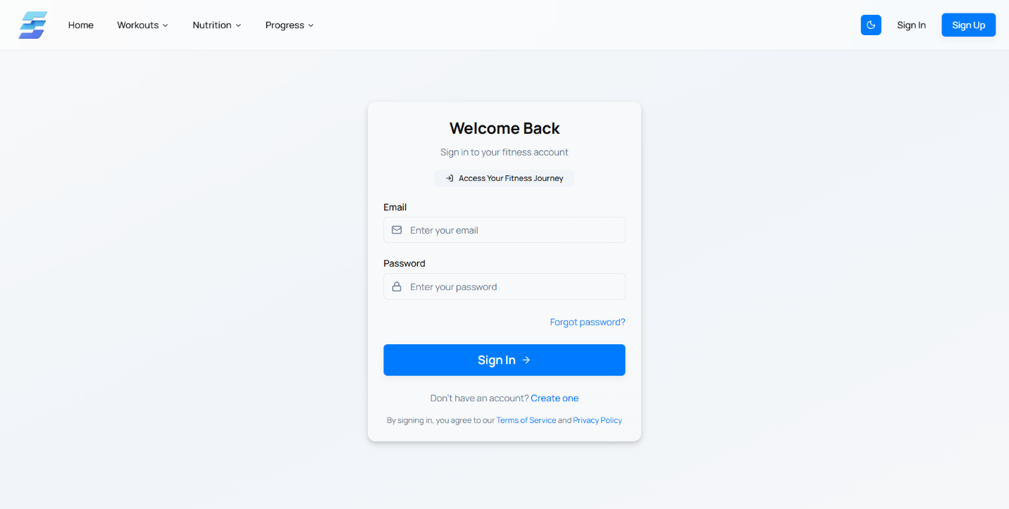

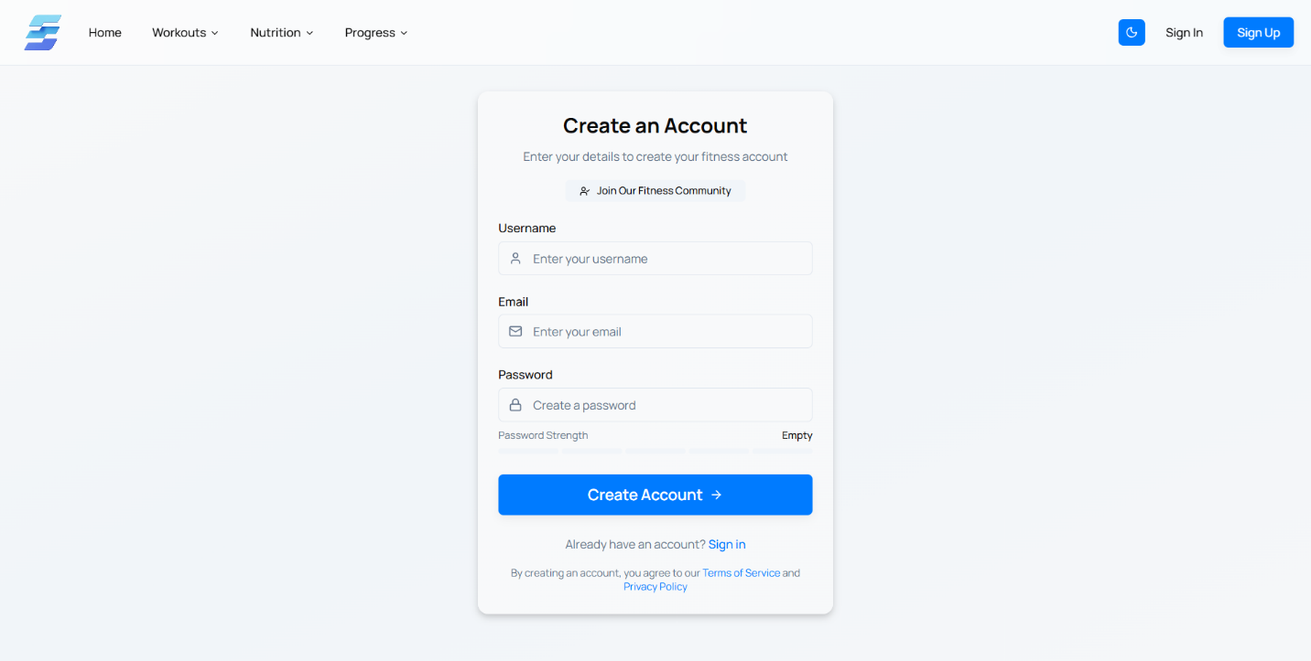

**DASHBOARD**

A Place which feels like home to the users as there tracking system

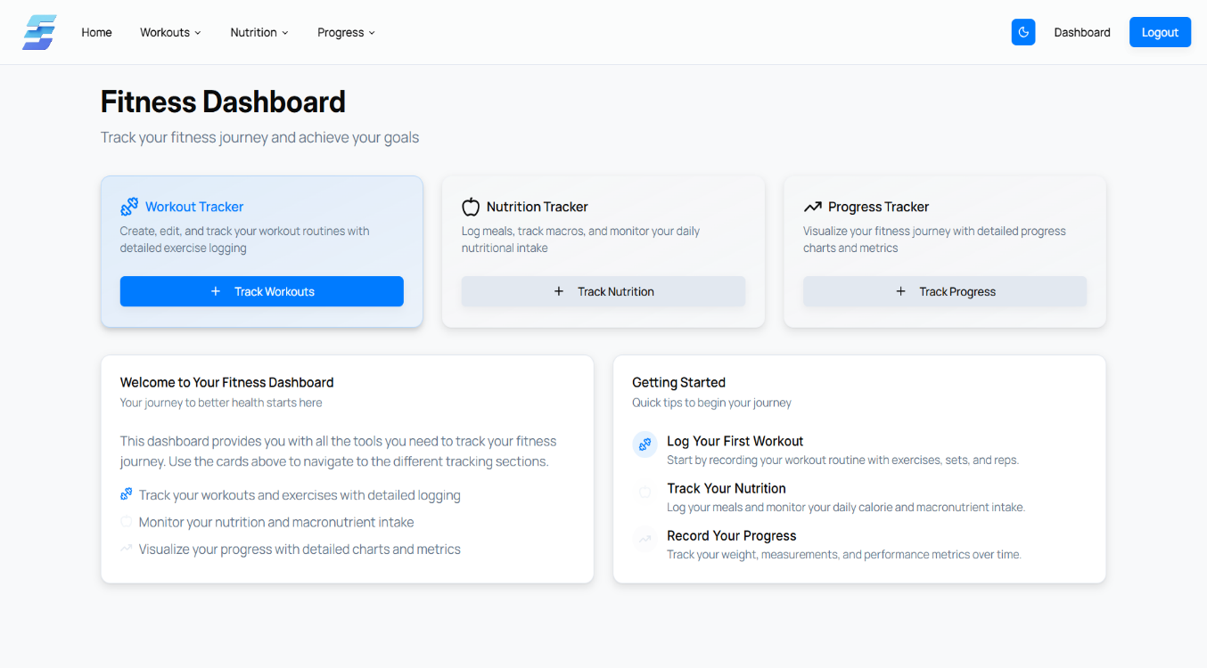

**WORKOUT TRACKER**

A Place where user can add different workouts to make sure that he is doing right!

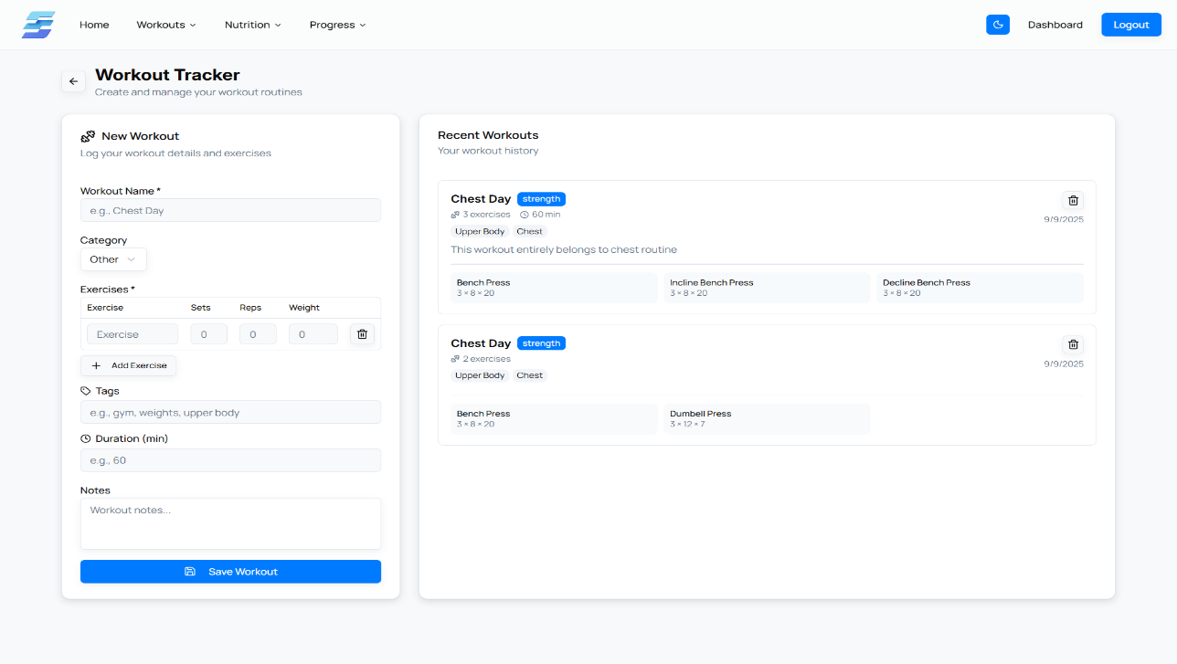

**NUTRITION TRACKER**

A Place where user can track its calories and nutrition to make sure that he is getting the right gains!

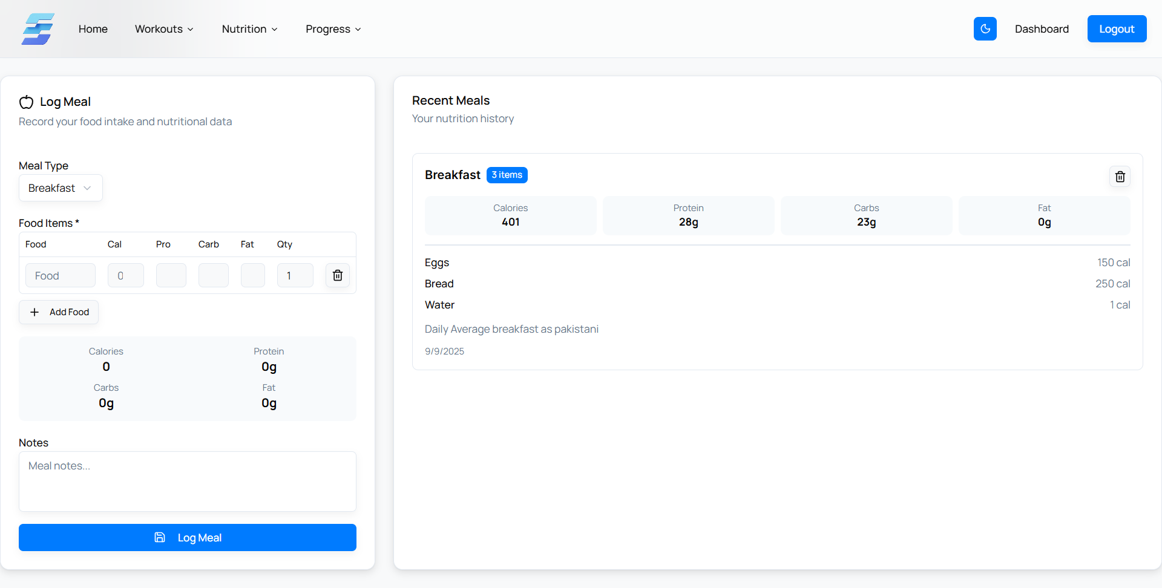

**PROGRESS TRACKER**

A Place where user can track its progress of each body measurements

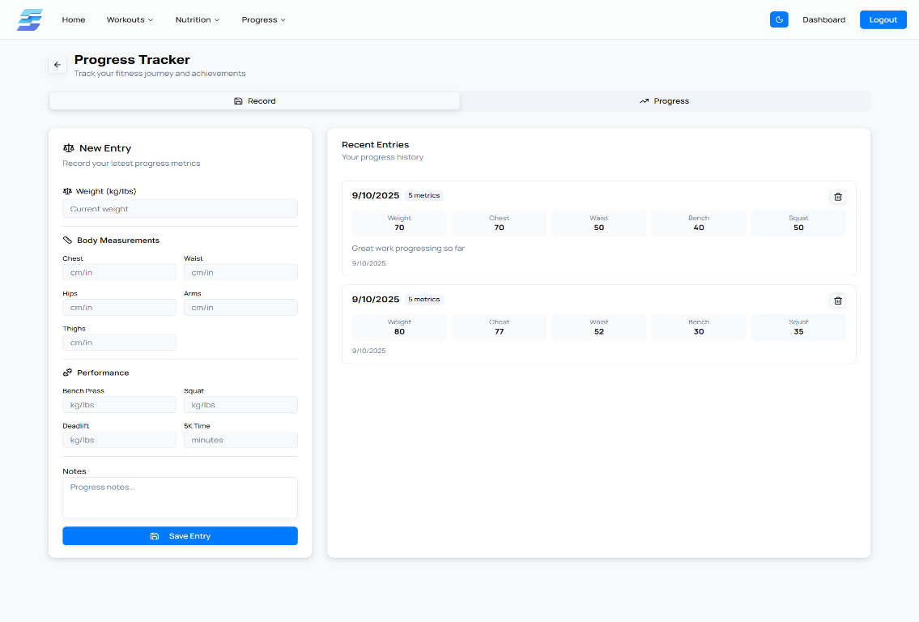

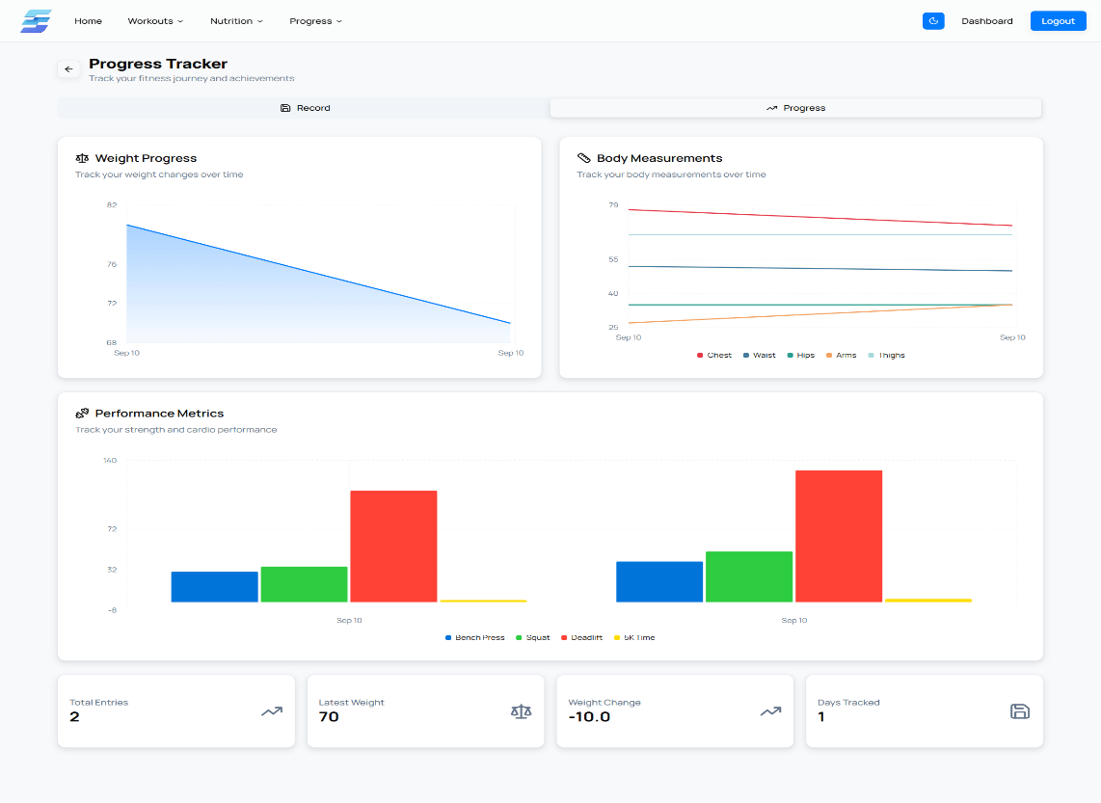

**THANK YOU!**